Kamiak “Windust” White

– Washington State
• COMPOSITION: 83% Chardonnay, 10% Riesling, 7% Gewürztraminer
• pH: 3.35
• TA: 7.2 g/L
• RS: 0.8% • ALCOHOL: 13.5%
• BOTTLED: June 2014
• PRODUCTION: 1,464 cases
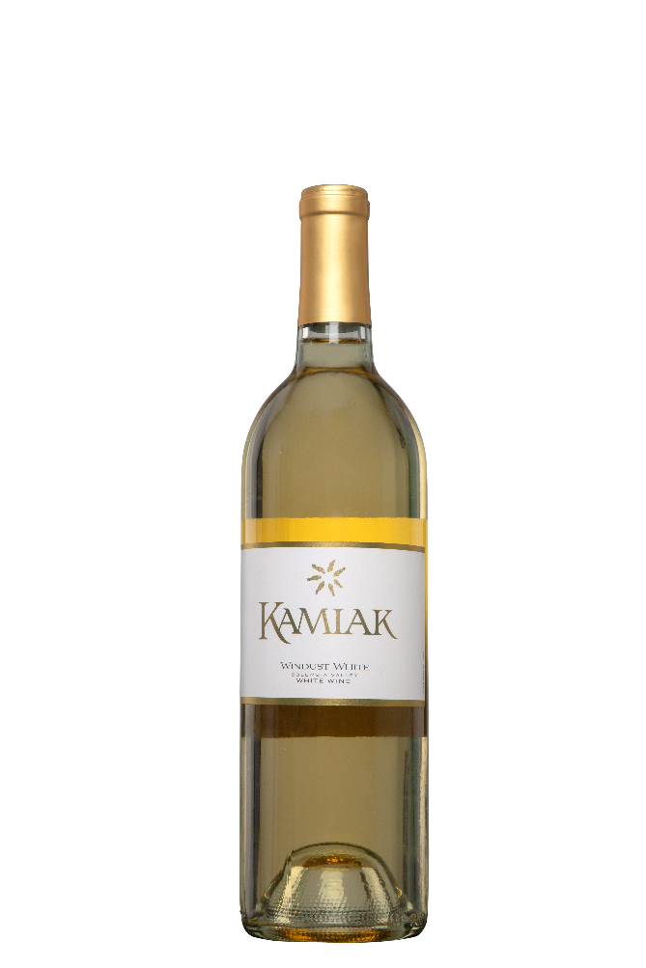
WINEMAKING
The key to Kamiak White lies in the artful blending of multiple grapes to achieve a wine with a unique personality, showcasing the best of its individual components. The backbone of the Windust White is Columbia Valley Chardonnay. Whole cluster pressed and fermented in a mix of stainless steel and oak barrels, this wine brings lush fruit and body to the blend. In addition to our spicy and aromatic Gewürztraminer we also included one of Washington’s signature grapes, Riesling. This final ingredient helps lift the aromas of the wine and provides a floral intensity that compliments the Gewürztraminer. We are very proud of the result and we know that you will enjoy this wine.
WINEMAKER COMMENTS
Pear, jasmine and honeysuckle explode from the glass, filling the nostrils with luscious aromas. Sweet flavors of ripe summer fruits and exotic flowers roll across the palate, followed by a crisp finish that leaves you wanting for another sip. With flavors and aromas to spare, you will find this wine is quite versatile as a warm weather quencher or as a great start to a fine meal.

